
PERSONAL PROTECTION, INC.
Whether you live in the “Concrete Jungle”, the “Suburbs”, or the “Country”

“Your Personal Safety is our Primary Concern”

NRA FIREARMS INSTRUCTOR
DEVELOPMENT/CERTIFICATION COURSE ANNOUNCEMENT
FOR APRIL/MAY 2018
 !These will be my only NRA Instructor Courses scheduled for 2018!

February 01, 2018

Dear Prospective NRA Firearms Instructor:

Enclosed you will find an Information Package with dates and prices for the next scheduled NRA Firearms Instructor Development Courses. Please look over the Announcement carefully as the NRA does require some pre-requisite information & skills, which you must provide to the Training Counselor prior to Enrolling in, or taking, any of these courses. Pre-Qualification information will be emailed only to thoses students who wish to take these courses.

The three Pistol related Instructor Courses will be offered on Apr. 27th, 28th, & 29th (Friday, Saturday, & Sunday), with the Rifle & Shotgun Instructor Courses and Range Safety Officer Course on May 4th, 5th, & 6th (Friday, Saturday, & Sunday). The Chief Range Safety officer Course will be held on May 20th (Sunday).

Please look at the enclosed Information Package & Enrollment Form and if you are interested in taking any of the scheduled courses, email or call to reserve a seat until you can complete and return the Enrollment Form. Please return only the Enrollment Form and not the rest of the Information Package. Detailed instructions are enclosed in the package as well as other supplemental information.

On the Enrollment Form you will find substantial $discounts$ for enrolling in multiple courses (3 or more), and you can secure your seat with a 50% deposit VIA cash, check, money order, Master Charge, Visa, American Express, or Discover, with the balance not due until, or before, April 15, 2018. Late Enrollment Fee of $100 appies after the 15th.
Plan now to enroll in the NRA Firearms Instructor Course(s) you have been wanting to take.

These NRA Instructor Courses usually fill up quickly (within 2-3 weeks) after the announcement, so if you are interested in completing any of the courses, please contact me as soon as possible to make sure you reserve your seat. I hope to see you in class in the April/May Courses (the only NRA Courses I have scheduled in 2018).

Cordially,

Terry L. Haddock
President & Chief Training Officer, Personal Protection, Inc.
NRA Training Counselor
NRA Benefactor Life Member
NRA Chief Range Safety Officer
NRA Law Enforcement Firearms Instructor

tlhaddock@personalprotectioninc.com www.personalprotectioninc.com

IMPORTANT NOTICE ~ PLEASE READ

Do not enroll in these courses if you are a beginner, or you are not relatively proficient with the firearms that you would like to be able to teach other individuals or groups to use safely. These are not beginner’s courses, they are Instructor Certification Courses.
The NRA does require a certain level of proficiency to take these courses.
The NRA Pre-Qualification paperwork will be emailed to interested students.

The courses you will be able to teach, after becoming NRA Certified, are not “Concealed Weapons” courses, however the NRA Courses do meet the State of Florida requirements for your Students to show “proficiency” to apply for the Florida Concealed Weapon
or Firearm License.
If you provide NRA Certified Courses and materials to your students, you will be able to issue “Official” NRA Certificates to your Students who complete those courses. Your Students can then use those NRA Certificates to apply for the Florida Concealed Weapon or Firearm License.
~

For additional information, call 954-967-4633 or 954-325-0911
or go to the web page below, click on the "Free Downloads" tab and
download the information as a
"PDF" or "Word" file.

Call or email if you have questions.

www.personalprotectioninc.com
tlhaddock@personalprotectioninc.com

Only “Official” Enrollment Forms that are accompanied with 50% deposits or full payments will be accepted to reserve seats in these courses.
A phone call or email to Mr. Haddock will reserve a seat for only 3 days until the Enrollment Form and payment can be delivered to him VIA email, snail mail, or by hand.
Unfortunately, due to several past experiences,
there can be no exceptions for securing a seat.
~ Thank you for your cooperation ~
NRA

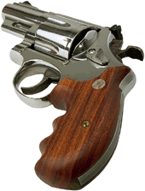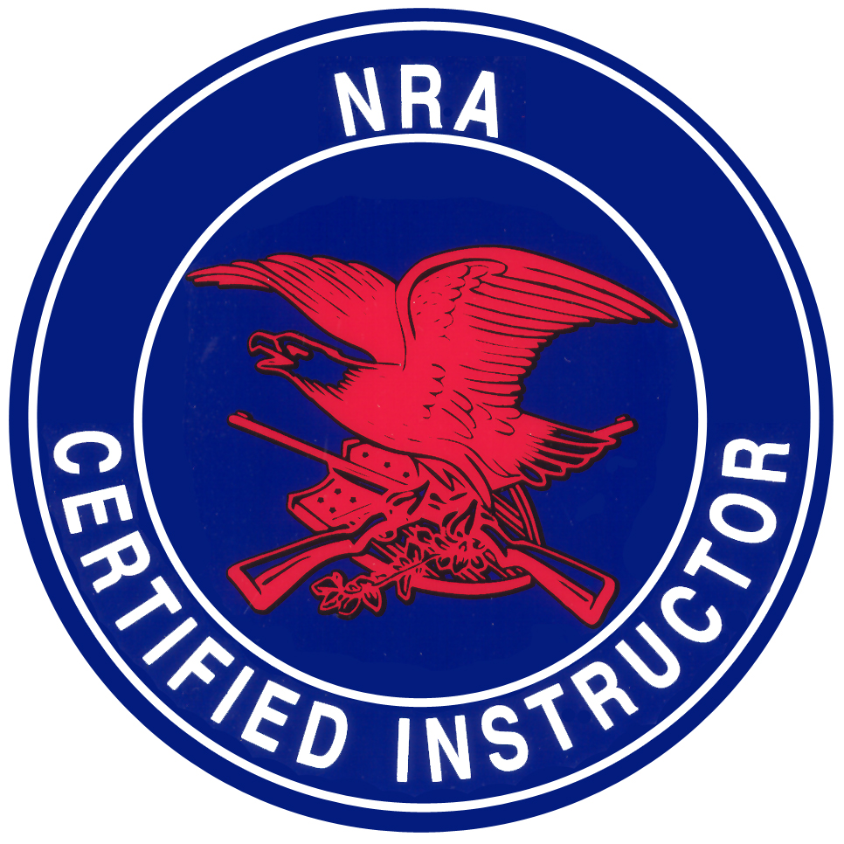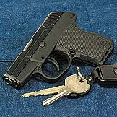

FIREARMS INSTRUCTOR
CERTIFICATION COURSES

ENROLLMENT FORMS ENCLOSED

SEVEN NRA CERTIFIED COURSES TO BE HELD:
Apr. 27, 28, 29, & May 4, 5, 6, & 20, 2018

BASIC FIREARMS INSTRUCTOR COURSES BEING OFFERED:

BASIC INSTRUCTOR TRAINING (BITRequired), HOME FIREARMS SAFETY INSTRUCTOR (1),
BASIC PISTOL INSTRUCTOR (2), PERSONAL PROTECTION IN THE HOME INSTRUCTOR (3),
BASIC RIFLE INSTRUCTOR (4), BASIC SHOTGUN INSTRUCTOR (5) RANGE SAFETY OFFICER (6)
& CHIEF RANGE SAFETY OFFICER (7)
CHIEF INSTRUCTOR:
TERRY L. HADDOCK
NRA TRAINING COUNSELOR

YOU CAN BECOME AN

ENROLL IN THE COURSES TODAY!

tlhaddock@personalprotectioninc.com

www.personalprotectioninc.com

NRA
CERTIFIED FIREARMS INSTRUCTOR COURSES

NOTICE: THESE COURSES FILL QUICKLY. THERE WILL BE SEATS FOR THE FIRST 20 STUDENTS ONLY!

Thank you for your interest in the NRA Instructor Certification Courses that are now forming. The NRA needs men and women like you, now, more than ever, to train others in the safe and responsible use of firearms. I am a Commissioned NRA Training Counselor, and have been an active Instructor in Law Enforcement (Rangemaster, Hollywood P.D.), Security, and Private Training for many years. I am pleased to announce the following courses for you to become NRA Certified Basic Firearms Instructors, Range Safety Officers, or Chief Range Safety Officers.
THE NRA FIREARMS INSTRUCTOR CERTIFICATION COURSES:
APR. 27, 2018 BASIC INSTRUCTOR TRAINING (BIT) & HOME FIRFARMS SAFETY INSTRUCTOR COURSE (1)
APR. 28, 2018 BASIC PISTOL INSTRUCTOR COURSE (2)
APR. 29, 2018 PERSONAL PROTECTION IN THE HOME INSTRUCTOR COURSE (3)
MAY 04, 2018 BASIC RIFLE INSTRUCTOR (4)
MAY 05, 2018 BASIC SHOTGUN INSTRUCTOR (5)
MAY 06, 2018 RANGE SAFETY OFFICER COURSE (RSO) (6)
MAY 20, 2018 CHIEF RANGE SAFETY OFFICER COURSE (CRSO) (7)
Attendance of all Instructor Courses (1-5) is suggested, but not required. Attendance of the first six hours of Basic Instructor Training on the day of the Home Firearms Safety Instructor Course is mandatory for anyone who wants only one or two of the other Instructor Courses (This does not apply to the RSO Course). One or more instructor ratings are required to take the RSO course (6), but you can take the Instructor course(s) and the RSO course, then apply to the NRA for both at the same time).The RSO Course is a prerequisite for the CRSO.

THESE COURSES MEET THE STATE REQUIREMENTS TO TEACH THE CONCEALED WEAPON COURSE IN THE STATE OF FLORIDA. ALL COURSE BOOKS, OUTLINES, LESSON PLANS, & HANDOUTS ARE INCLUDED IN THE COURSE FEE. (The RSO Course is an NRA Certified course, but not an Instructor level course. It is designed for anyone who works at, or wants to work at, a public, private, or police shooting range, and can help to lower the range's insurance costs). RSO is also helpful in limiting individual Liability for Instructors.

THE FEES:
The course fee for the five Instructor ratings is $650.00, or all six ratings including RSO for $750.00, if paid in full by APR. 15, 2018. (The fee after APR. 15, 2018 is $750.00 for the first five or $850.00 for all six). You can take any 3 Instructor courses for a fee of $550.00, or $650.00 with RSO. Add $100.00 if after 04/15/18. The fee for a single course is $250.00 plus $100.00 for BIT ($350.00 Total). Reservations are required with a minimum 5O% deposit to save your seat for these courses. Deposits or full payments can be made by cash, check, money order, Master Card, Visa, American Express, or Discover. Credit cards will be charged the same day the Enrollment form is received (no exceptions). Please call first to make credit card arrangements.
Make checks or money orders payable to:
Personal Protection, Inc., Post Office Box 222132, Hollywood, FL 33022

PLEASE READ OUR REFUND POLICY CAREFULLY:
If you are unable to attend on the day of the course(s), for any reason, you will be given a credit slip, which will allow you to take the course(s) at the next scheduled class only. Because of the expenses involved in preparing for these courses, including the Pre-Qualifications, there will be no refunds for student cancellations. A fee or deposit will be refunded only if the Instructor cancels the course(s) and then only if the student has not previously attempted and failed the NRA required pre-qualification(s). There will be no refunds for any Student who fails the pre-qualification(s). If the Instructor cancels the course(s), and the Student has not failed the pre-qualifications, refund checks will be mailed within 30 business days. Please remember BIT, on the first day, is mandatory to take any other Instructor Course(s).

LOCATION:
The Course location will be in Hollywood, Fl., (with map & hotels), and will be announced with acceptance of your Enrollment Form.

OTHER COURSES AVAILABLE:
Close Quarter Combat Pistol, Dim Light, Shoot/Don't Shoot, Combat Shotgun, Urban Rifle, Chemical Weapons, Taser, and Tactical Baton. (These courses are user-oriented courses, not instructor level courses, but also require some previous basic training).

For further information, call either number below:
- TERRY L. HADDOCK, NRA TRAINING COUNSELOR -
P.D. Office: (954) 967-4633 or Cell Phone: (954) 325-0911
(If an answering machine answers, please leave your name & number & I will return your call as soon as I can).
tlhaddock@personalprotectioninc.com www.personalprotectioninc.com

NRA CERTIFIED INSTRUCTOR COURSES
& ADVANCED TACTICAL COURSES

- THIS “OFFICIAL” ENROLLMENT FORM MUST BE RETURNED WITH PAYMENT -
This form must be filled out completely to be processed for a seat in any of the classes beloW.

Please enroll me in the following course(s). Place a checkmark beside the course(s) you want:
Course Title Course# Course Fee
NRA INSTRUCTOR LEVEL COURSES*
____ Basic Instructor Training (BIT)* $100.00 * If taking 3 or more Instructor courses
____ NRA Home Firearms Safety Instructor (1) $250.00 BIT is included at no charge.
____ NRA Basic Pistol Instructor (2) $250.00
____ NRA Personal Protection Instructor (3) $250.00
____ NRA Basic Rifle Instructor (4) $250.00 Please circle an amount below if
____ NRA Basic Shotgun Instructor (5) $250.00 taking the RSO with other courses
____ NRA Range Safety Officer(RSO) (6) $250.00 & place that amount in Total Fees.
____ First Three NRA Instructor Courses (1-3)* $550.00* or $650.00 with RSO (6), or $750 with CRSO (7)*
____ All five NRA Instructor Courses (1-5)* $650.00* or $750.00 with RSO (6), or $850 with CRSO (7)*
____ Chief Range Safety Officer (CRSO) (7) $250.00 (BIT &RSO is a prerequisite)
____ Refuse To Be A Victim Course (RTBAV) $ Call for Group Rates (10 minimum)
____ NRA Refuse To Be A Victim Instructor (8) $250.00 (RTBAV is a prerequisite)
____ Close Quarter Combat Pistol (CQCP) $225.00 (Previous experience required)
____ Close Quarter Combat Shotgun (CQCSG) $225.00 (Previous experience required)
____ Tactical Expandable Baton (BAT) $125.00 (Vigorous- physically demanding)
____ Chemical Defense Spray (CDS) $ 75.00 (You don’t have to get sprayed)
____ Defensive Tactics/Handgun Retention (DTHR) $125.00 (You don’t have to be a Black Belt)
____ Basic Taser User Course (TAS) $125.00 (Must have own Taser & 1 Cartridge)
*COMBINATION OR MULTIPLE COURSES WITH DISCOUNTED FEES (must be paid in full on or before Apr. 15, 2018).

Total Fee(s) Enclosed - $_________ Full payment, or - $_________50% deposit

Check Mark One Please - Payment is by: ( )Cash ( )Check ( )MO ( )MC ( )Visa ( )Amex ( )Discover ( )PO*

*Purchase orders must be attached and will be accepted from city, county, state, or federal agencies only.
(All Credit Card Payments will be processed upon receipt by Personal Protection, Inc.)
Completed Enrollment Forms with Credit Card payments can be emailed back to: tlhaddock@personalprotectioninc.com
All Check or Money Order payments must be made payable to: Personal Protection, Inc.,
with Enrollment Forms and payment mailed to: Post Office Box 222132, Hollywood, FL, USA 33022

Credit Card Account Number:_____________________________________________________ Exp. Date: _________________

Exact Name on Credit Card:______________________________________________________ Inv # (on back of card ) :___ ___ ___

Signature of Credit Card Holder:_______________________________________________________________ PPI Authorization Code___________
 By signing this form I give my consent to Personal Protection, Inc. to charge my credit card the above amount (Total Fees). - Please Leave above Auth. Code blank.
  I also understand and agree that there are no refunds for any reasons, of any kind, for student cancellations for any of the course(s) the student has enrolled in above.

Please print clearly or type the following information!

Name: ________________________________________________________________ NRA Member#_______________________________*

Address: ________________________________________________________________ Circle: Male/ Female Age ____________**

City: _____________________________________________________________________ State: _________________Zip: ______________

Work Phone: _________________________________________ Home/Cell Phone: ___________________________________________

Police, Military or Security Affiliation:________________________________________ Email Address:_____________________________

***Previous firearms experience: ___________________________________________________________________________

* (NRA Membership is encouraged but not required to take these courses)
** (Age is requested by NRA To be a Certified Instructor, Student must be 21 years of age or older)
*** (Previous firearms related experience is mandatory to take any of the NRA Firearms Instructor Courses or the RSO Course)
tlhaddock@personalprotectioninc.com www.personalprotectioninc.com

